Airport Information:
Shanghai Pudong International Airport (PVG)
上海浦东国际机场
Shànghǎi Pǔdōng Guójì Jīchǎng

Arrival:
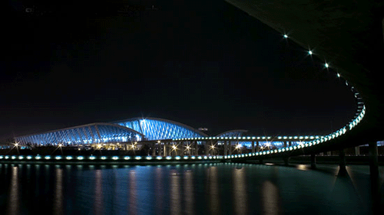
We will be departing from Terminal 2 (T2 opened March 28, 2008)
Terminal 1 = domestic and international flights (including American Airlines and Japan Airlines)

Terminal 2 = domestic and international flights (including Northwest Airlines, United Airlines, and Air China)

We will have likely have at least 2 hours in this airport before we depart at 10:00am (according to our current schedule).

Phone:
Call the U.S. from China:  001 + 1 + Area Code + Tel. # | Call China from the U.S.:  011 + 86 + City Area Code + Tel #  (Shanghai City Area Code = 21)
Time zone in China:
GMT +8
12 hours ahead of Notre Dame;
13 hours ahead of Omaha;
18 hours ahead of Hawaii
Bank:

1 U.S. dollar = 7 Chinese Yuan (元)

There are many banks throughout the airport. In our area, the quickest is the
Bank of China (between Gate 15 and Gate 16 in International Departures area) or
the Industrial & Commercial Bank of China (between Gate 12 and Gate 14 in International Departures area)

Be sure to convert all or some of your leftover yuan back into dollars here if you want. The exchange rates in China are a little better than in the U.S. (It might also be a good idea to keep some yuan as a souvenir).

Notes:

You are expected to obey any Chinese airport rules (as well as American) when here
Remember restrictions on liquids in carry-on baggage.
Also be prepared to show your passport at customs and fill out any kind of paperwork that is required (e.g. China customs declaration card)

Details:

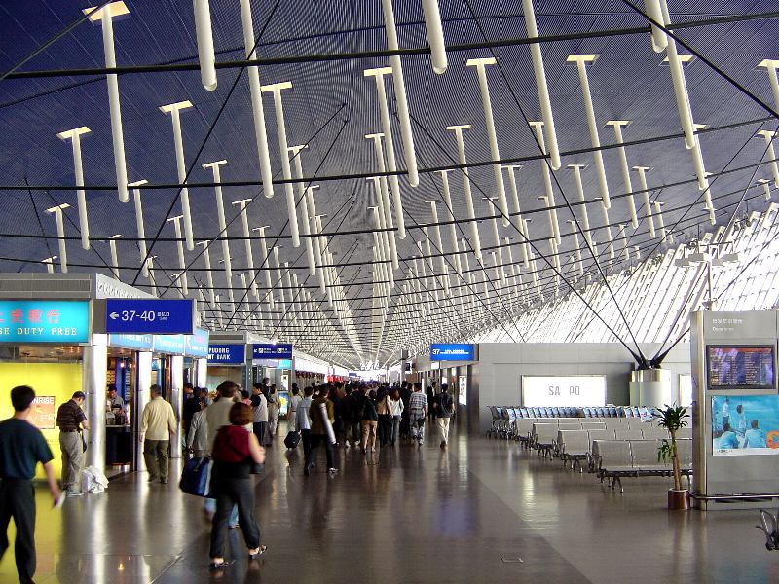
Pudong airport is primarily an international airport serving Shanghai of the People's Republic of China. Located about 30km (19 miles) from the city center, it occupies a 40km (25 miles) square site adjacent to the coastline along the eastern edge of Pudong district within the boundaries of the Shanghai Municipality. The airport is organized around two main passenger terminals, flanked on both sides by three parallel runways.
A station for the Shanghai Maglev Train is sited between the passenger terminals, providing the world's first commercial high-speed maglev service to downtown Pudong in 7 minutes and 20 seconds. The airport is open 24 hours a day, one of the few Chinese airports to do so.
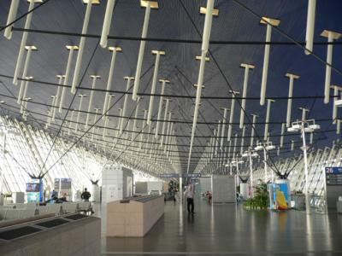
The airport handles more international passengers than Beijing Capital International Airport (which is currently the busiest Chinese airport). Terminal 2, located behind Terminal 1, opened on March 26, 2008 (same day as the official opening of Terminal 3 at Beijing Capital International Airport), adding an additional capacity of 40 million passengers a year. It has given the airport a capacity of 60 million passengers and 4.2 tons of cargo annually.
Terminals & Gates (see airport map):

The airport has two huge, three-story terminals.

Terminal 1 serves American Airlines, Continental Airlines, Delta Airlines, Air France, China Eastern Airlines, Japan Airlines, and Korean Airlines (among several others)

Terminal 2, the newest terminal (opened March 26, 2008), serves (as of April 29, 2008) Northwest Airlines (Tokyo-Narita), Air India, British Airways, Shanghai Airlines, Air China, Air Canada, China Southern Airlines, and United Airlines (among several others)
Restaurants and Shops:
Dozens of restaurants can be found within Shanghai Pudong International Airport. Two of the most famous establishments are Canglang Ting Restaurant and Hong Fangzi Western Food Restaurant

Fun Facts:
- Current airport masterplans call for the building of a third passenger terminal (currently in the planning stages), a satellite terminal and two additional runways by 2015, raising its capacity from the current 60 million passengers annually to 80 million
- Pudong is the fifth busiest airport in the world in terms of freight traffic
- It is the eighth-busiest airport in Asia in passenger traffic
- A third terminal is currently at planning stage
- The airport is open 24 hours a day, one of the few Chinese airports to do so

Customs
All inward/outward passengers, except those who are exempted from Customs inspection and control in accordance with relevant regulations or those under the age 16 who are traveling with accompanied adults, shall make a factual declaration to the Customs at airports of entry by completing a Declaration Form.
Passengers who select “No” in all the items on the Declaration Form may choose to go through “Nothing-to-declare Channel”(“Green Channel”) for Customs procedures. (this will be us, unless you have something you really want/need to declare).
Those who select “Yes” in the items on the Declaration Form shall provide in the corresponding spaces such details as details as description (type of currency), quantity (amount),model, etc., before choosing to go through “Goods-to-declare Channel”(“Red Channel”).

